**Driver Changeover Vehicle**

***Work-flow to Use Driver Changeover Vehicle***

The Driver Changeover Vehicle preference is accessed through **Load Template** and only one instance of it is permitted.

***Preference Overview***

This preference sets

***Templates Available from Optibus***

***Driver Duty Work Time Preference***

**Purpose:**

As stated in the Overview **Prerequisites:** None. **Opening Dialog:**

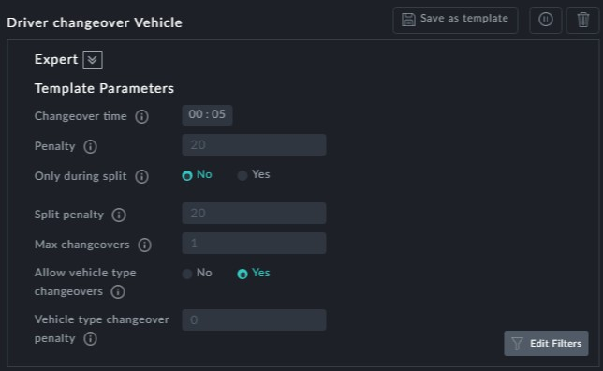

**Points to note:**

**Changeover time**: Time set for a vehicle changeover



**Penalty**: This penalty applies to each changeover. Set it high to reduce changeovers and vice versa.



**Only during split** and **Split penalty**: Setting the Split penalty high reduces the num- ber of changovers during splits



**Max changeovers**: How many changeovers allowed in one duty



**Allow vehicle type changeovers** and **Vehicle type changeover penalty**: Setting the penalty high tends to reduce vehicle type changeovers

